The Gender Pay Gap Increases to 18.2 Percent in 2017

According to ONS data, men earned 18.2 percent more than women in the United Kingdom during 2017.

Since 2011, the pay gap for all employees has decreased by 1.8 percent, but increased by 0.2 percent in the last year. Data for full-time employees indicate even less of a change, with only a 1.4 percent decrease in the last six years.

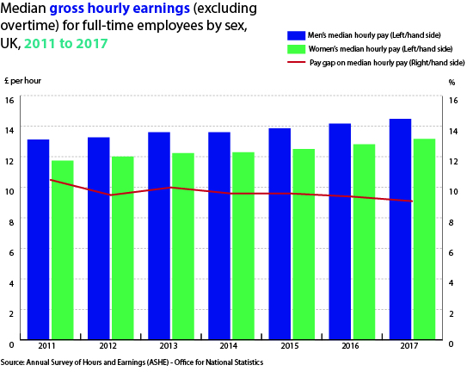

The above graph demonstrates the mean hourly pay for full-time employees of both genders. The red line indicates the percentage pay gap over the six-year period. The graph visualises how minimal the change has been since 2011.

The ONS determines the gender pay gap by finding the difference between men’s and women’s median salary. The data considers a variety of other factors, including location, age and occupation.

Occupation has one of the strongest impacts on the pay gap. The pay gap is consistently in favour of men, but varies depending on the profession. Jobs stereotypically associated with women, such as administration, demonstrate a lower pay gap at about 6.2 percent. However, salaries of health professionals have a 17 percent gap.

This data considers the median pay of the middle 80 percent of earners – excluding most outliers – but it does not consider several factors, such as the impact of domestic responsibilities on skill-building and hours, gender segregation, the proportion of women to men in specific occupations, and quality of work.

Not all equality variables are empiric. Though longevity does not solely equate experience, tenure still provides an idea as to how women’s experience is valued in comparison to men’s experience.

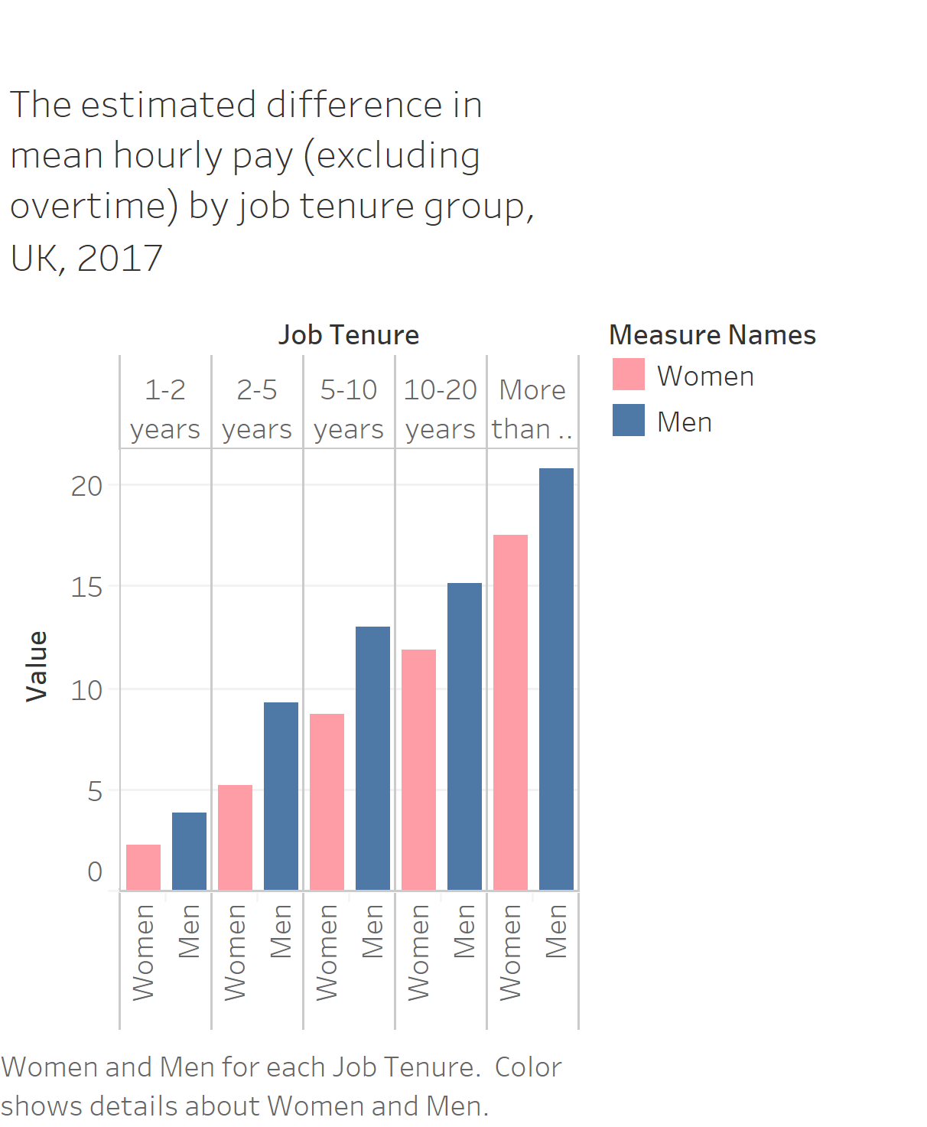

The graph above demonstrates that female salary grows with tenure, but the gap does not decrease. Additionally, experience generates a higher and longer salary growth for men than it does for women.

Sam Smethers, the chief executive of Fawcett Society notes that women enter the workforce with an existing pay gap which “has grown since last year suggesting that we are going backwards not forwards. As women progress in their working lives their value relative to their male colleagues declines”.

The government first addressed the gender pay gap 38 years ago with the passing of the 1970 Equal Pay Act, superseded by the 2010 Equal Pay Act. Though the gap has since decreased, it remains overwhelmingly in favour of men. More recently, the government has required all companies with at least 250 employees to publish figures related to the gender pay gap by April 2018. Only a fraction of the companies have done so, despite only four months remaining until the deadline.

The October New York Times report about Harvey Weinstein inspired a social movement driven by women vocalising their experiences with workplace harassment and, by extension, all workplace inequality. Recently, the topic has frequented the news cycle with some high-profile women quitting their jobs including E! New anchor Catt Sadler and BBC China Editor Carrie Gracie.

Chloe Varty, a financial analyst at Johnson & Johnson says “In the last few months, I’ve seen a shift in the workplace environment. Female co-workers have become more assertive, asking questions in attempt to find transparency regarding salary equality”. While fair comparisons will indicate that legal efforts to enforce equality in a workplace are making a difference, it is evident that social inequality and gender expectations are leading factors of the gender pay gap. The issue may need to be addressed at a younger age to change and equalise career expectations of both genders. Perhaps the current social climate will incite a more significant change than there has been in the last six years.

Methodology

**Graph 1**

The line + bar graph format was chosen to demonstrate two different relationships. The bar graph (referenced by the left-hand side) compares male and female salaries. The line graph (referenced by the right-hand side) demonstrates the percentage pay gap based on the differences in salaries. It visualises the gender pay gap, laying the foundation for the article.

**Graph 2**

A paired column format was chosen to compare the impact of tenure on salary for both genders. There is enough significance between men’s and women’s data that a column graph adequately demonstrates the differences. This graph visualises how experiences are not valued equally for both genders.